BOOK LIST
GRADE SIX
MATHEMATICS | SOCIAL STUDIES | SCIENCE | LANGUAGE ARTS
- Developing Mathematical minds 1 and 2  - SEA 32  - NGSA past papers 2009 to 2022  - First Aid in Mathematics  - Graded mathematics for Guyana primary schools | - Social studies for all  - NGSA past papers 2009 to 2022 | - Science for all  - NGSA past papers 2009 to 2022  - Lable me | - Process of learning Language  - Process of learning Composition writing  - Process of testing Language  - Understanding English Grammar  - First Aid in Spelling  - NGSA past papers 2009 to 2022

Grade 5 books to be carried over
- Process of learning Mathematics levels 4 & 5(one book)
- Process of testing Mathematics level 5
- Social Studies Made Easy
- Science Made Easy
- Science Around Us 5
- Social studies for our children 4 and 5(2 books)
- Junior English Revised
- Mastering Vocabulary
- Fun With Language 5

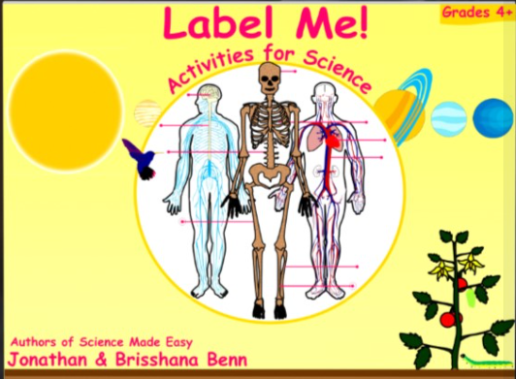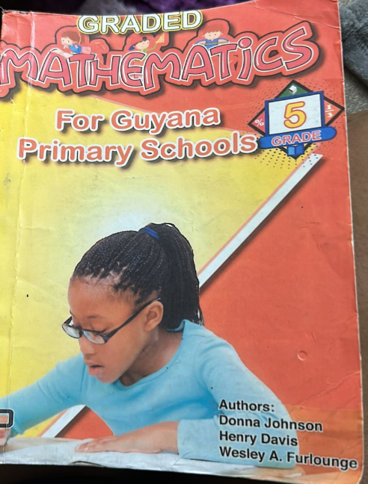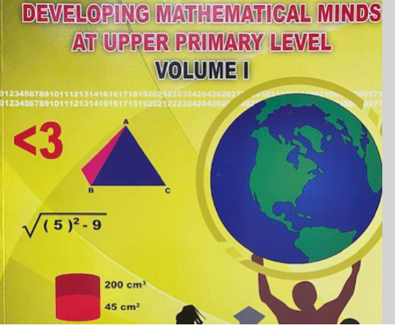

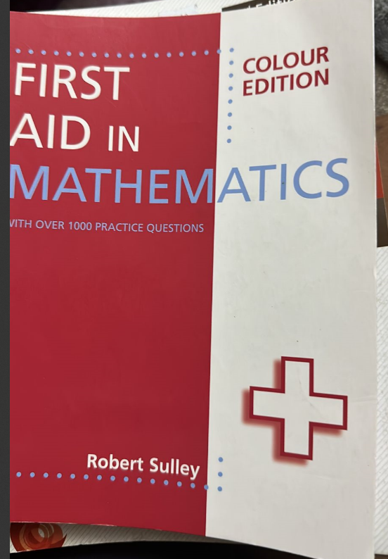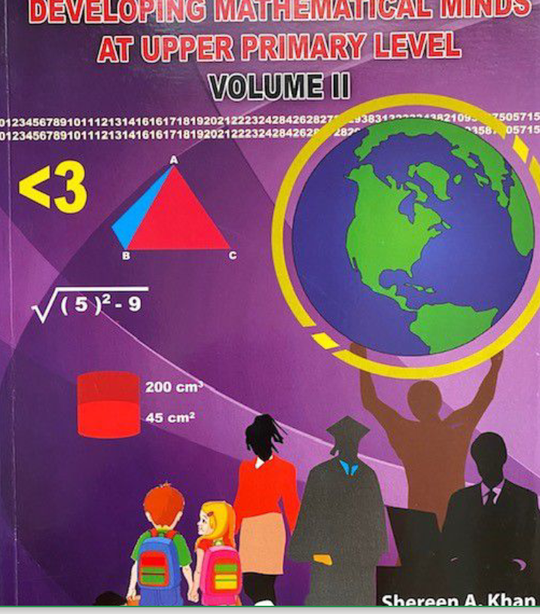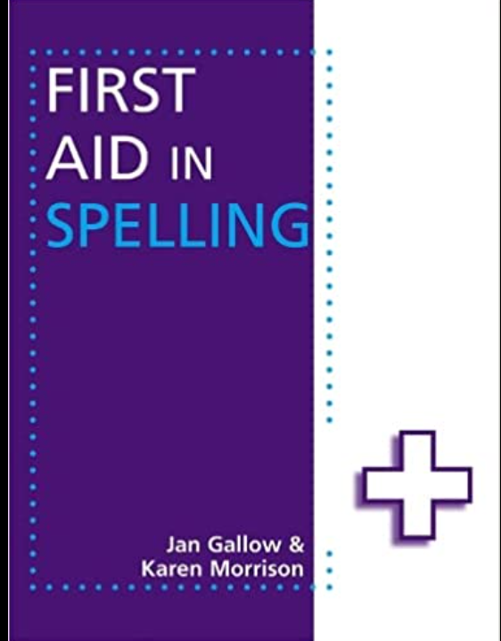
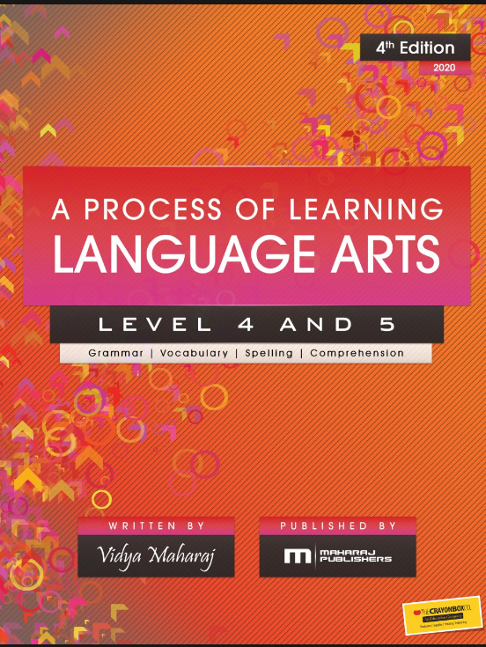 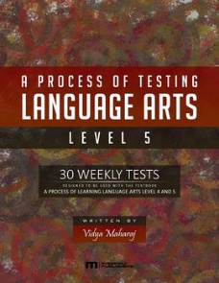 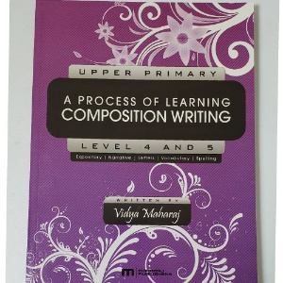 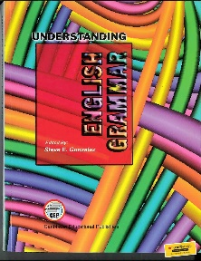 OR 